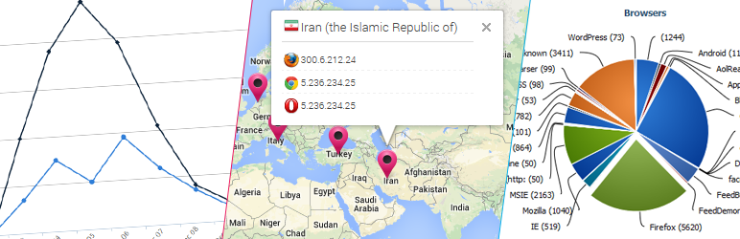

WP Statistics

Administrator Manual

Version 5.5

Table of Contents
Introduction 3
Features 4
Requirements 5
Main Interface 6
Settings Page 8
General Settings 9
Access/Exclusions 13
GeoIP 16
Maintenance 16
Optimization Page 17
Resources/Information 18
Export 19
Purging 20
Updates 20
Overview Page 21
Browsers Page 24
Countries Page 25
Hits Page 26
Exclusions Page 27
Referrers Page 28
Searches Page 29
Search Words Page 30
Visitors Page 31
Pages Page 32
The Widget 33
Shortcodes 34
Function API 36

Introduction
Welcome to WP Statistics!
This plug-in is designed to track your visitor statistics in WordPress, completely locally without any external services.
There are several key items to note about WP Statistics;
- No external services are required, all code and data runs locally on your system.
- Aggregate data is stored whenever possible, when specific data is required (like IP addresses for visitors) only the date is stored with the hit, not the time.
- This product includes GeoLite2 data created by MaxMind, available from http://www.maxmind.com.
This document will use a couple of conventions you should be aware of:
- Screen shots will generally exclude all of the WordPress admin menus to make keept them concise.
- Menu selections will be and other actions to be taken will be indicated with italics.
- If multiple menu selections are required, they will be seperated with ->, so for example if you are to go to the settings page, this document will indicate it with Statistics->Settings.
- If a page has tabs on it, they will be treated as menu items, so for example, if you are to go to the GeoIP tab on the Settings page, this doucment will indicate it with Statistics->Settings->GeoIP.
- In some sections you will find a “Developers Note”, these are items that a developer may find useful if they are looking to work with WP Statistcs, normal administrators or users can safely ignore these items.

Features
WP Statistics has many features:
- User Online, see how many people are currently viewing your site
- Visits, see how many hits your site gets each day
- Visitors, see who's visiting your site
- Page tracking, see which pages are viewed most often
- Search Engines, see search queries and redirects from popular search engines like Google, Bing, DuckDuckGo, Yahoo, Yandex and Baidu
- GeoIP location by Country
- Interactive map of visitors location
- E-mail reports of statistics
- Set access level for view and manage roles based on WordPress roles
- Exclude user roles from statistics collection
- Exclude robots from statistics collection
- Exclue IP subnets from statistics collection
- Exclude login/admin pages from statistics collection
- Record statistics on exclusions
- Automatic updates to the GeoIP database
- Automatically prune the databases of old data
- Export the data to Excel, XML, CSV or TSV files
- Overview and detail pages for all kinds of data, including; browser versions, country stats, hits, exclusions, referrers, searches, search words and visitors
- Widget to provide information to your users
- Shortcodes for many different types of data in both widgets and posts/pages

Requirements
WP Statistics requires a few things to work:
- WordPress 3.0 or above
- PHP 5 or above
- MySQL 5 or above
WP Statisitcs might work on older versions of the above software, but then again, it might not.
The GeoIP support also requires a few additional items to function:
- PHP 5.3 or above,
- the bcmath extension for PHP
- the cURL extension for PHP
- PHP cannot be running in safe mode
WP Statistics requires a significant amount of RAM for the statistics pages, especially the overview page, make sure to set your PHP memory limit high enough to support it. While every site has different memory requirements, a reasonable rule of thumb is approximately 36 megabytes.

Main Interface
WP Statistics adds a top level menu to your admin interface in PHP, you should see like this in your main admin page:
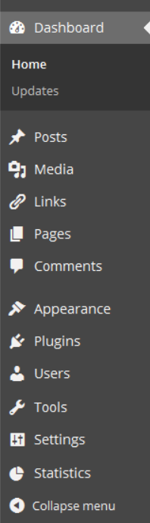
The Statistics menu will be located near the bottom of the list, clicking on it should bring up the following additional items:
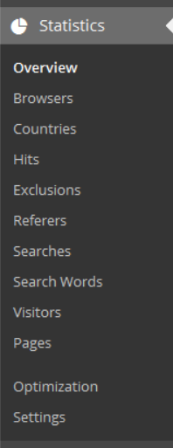
Each of these options will be discussed in the following sections.

In addition, if you've enabled the option, you may also see the WP Statistics menu icon in the main admin bar of your site as such:
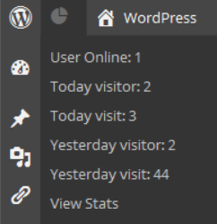
This menu gives you a quick summary of what is going on with your site and direct access to the overview page of WP Statistics.

Settings Page
The first thing you should do after installing WP Statistics is configure the plug-in, this is accomplished through the settings page.
Simply go to Statistics->Settings to get there. The main settings page looks like this:
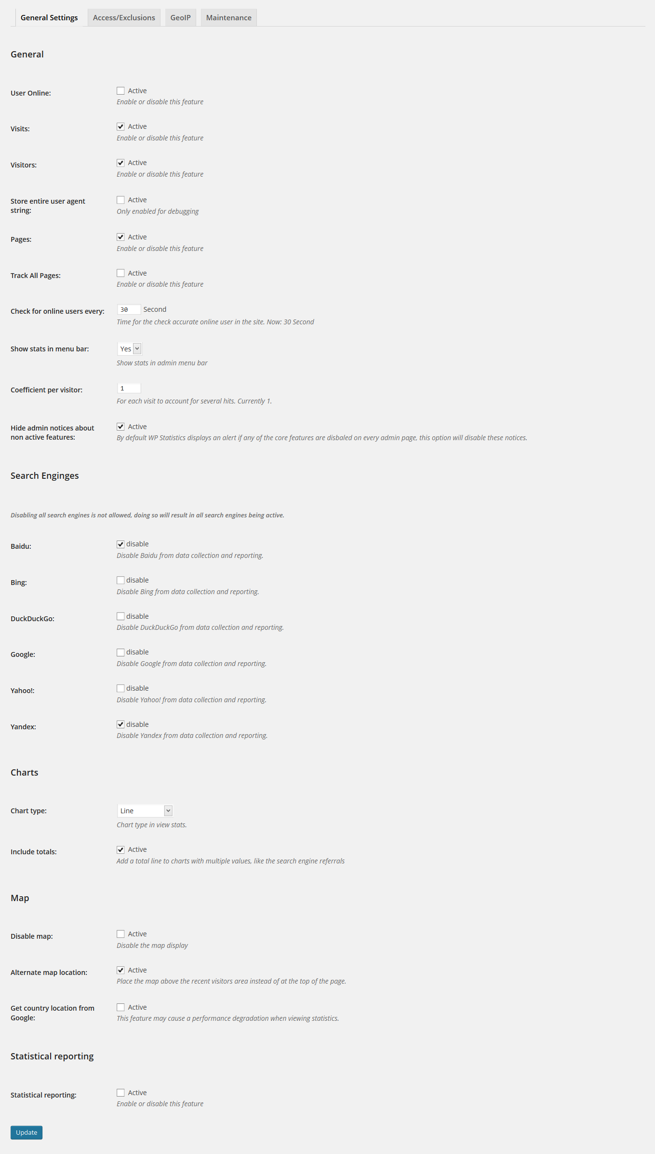
At the top are four tabs, each one will be addressed separately.

General Settings
The General Settings page has 5 subsections to it; General, Search Engines, Charts, Map and Statistical reporting.

General
The General section contains the primary configuration items for WP Statistics. These enable or disable the main features of the plug-in.
Setting | Values | Description
User Online | On/Off | This enables/disables the tracking of users that are online for your site.
Visits | On/Off | This enables/disables the tracking of visits (hits) for your site.
Visitors | On/Off | This enables/disables the tracking of visitors for your site.
Store entire user agent string | On/Off | If you have enabled Visitors, by default it stores the browser make, version and platform in the database by parsing the user agent (UA) string. However UA strings are very complex and parsing sometimes does not work correctly. In these cases you can store the entire UA string in the database so that it can be sent to the developers to troubleshoot the issue, or you can add it to the exclusions lists if it is a bot.
Pages | On/Off | This enables/disables the tracking of individual page hits.
Track All Pages | On/Off | By default, page tracking only tracks WordPress pages and posts, however you can enabled tracking of all pages (like category pages, RSS feeds, etc.) with this option.  Note: this will significantly increase the pages table and may make the top pages chart less useful as many system pages will likely be near the top.
Check for online users every | Number | If you have enabled Users Online tracking, this is how often they are checked for. If a user has not visited a page within this number of seconds, they will be considered offline.
Show stats in menu bar | Yes/No | This enables/disables the admin menu bar for WP Statistics.  Note: As the WP Statistics menu bar displays visitor stats, it adds load to your database for each admin page load.
Coefficient per visitor | Number | This is the number of hits each visitor is recorded for. Usually this should be left at 1, however if you have another plug-in that causes visitors to effectively connect to to your site more than once for each page view, this can be set to a lower value to account for that.
Hide admin notices about non active features | On/Off | By default, WP Statistics will warn you about any primary features that have been disabled (Online Users, Visits, Visitors, Pages and GeoIP). If you have disabled a feature on purpose or cannot support the GeoIP code, this option will remove the warning.

Search Engines
The Search Engines section contains the options for which search engines you want to track. By default all supported search engines are enabled, you may disable individual ones as required.
Note however that disabling all search engines is not allowed, doing so will result in all search engines being active.
Setting | Values | Description
Baidu | On/Off | Enable/disable Baidu.
Bing | On/Off | Enable/disable Bing.
DuckDuckGo | On/Off | Enable/disable DuckDuckGo.
Google | On/Off | Enable/disable Google.
Yahoo! | On/Off | Enable/disable Yahoo!.
Yandex | On/Off | Enable/disable Yandex.

Also note that geographic versions of the search engines are supported, so Google will include google.com as well as google.ca and other variations.
Developers Note:
The search engine list can be found in wp-statistics\includes\functions\functions.php in the function called wp_statistics_searchengine_list() (should be around line 297). You can add additional search engines by editing the $engines array, details are contained in the comments above the function. All other aspects of the search engine code relies on this array and no other aspects of WP Statistics needs to be changed to support the addition or removal of search engines.

Charts
The Charts section contains the options for the display of charts in WP Statistics.
Setting | Values | Description
Chart type | Line/Spline/Area/Area Spline/Column/Bar/Scatter | This lets you select the type of chart that is displayed for some of the statistics pages. Some items ignore this setting as only one chart type makes sense in those instances.
Include totals | On/Off | By default WP Statistics does not include totals in charts that have multiple values in them, this options enables a total value on any chart that supports them.

Map
The Maps section contains the options for the display of the GeoIP map in the overview page of WP Statistics.
Setting | Values | Description
Disable map | On/Off | By default the map is displayed in the overview page, however it can be disabled with this option.
Alternate map location | On/Off | The map's default location is at the top of the overview page, this option if enabled, will move it to above the “Recent Visitors” section.
Get country location from Google | On/Off | By default, the location of IP addresses for the map display are generated from the MaxMind database, however this can sometimes be out of date and this option will allow you to use Google instead. However this is MUCH slower as each address to be plotted requires a remote call to Google.

Statistical Reporting
The Statistical Reporting section contains the options to email the administrators the statistics.
Note if reporting is disabled, all other related fields will be hidden in the user interface.
Setting | Values | Description
Statistical reporting | On/Off | Enable/disable the reporting.
Time send | Hourly/Twice Daily/Daily | How often to send the report.
Send Statistical reporting to | Email/SMS | How to send the report, the blog's admin email address is used if email is selected.  To support SMS you must have WordPress SMS (http://wordpress.org/plug-ins/wp-sms/) installed as well.
Send Content Report | Text | This is the report text which will be sent, you can use the following variables in the report:  User Online: %user_online%  Today Visitor: %today_visitor%  Today Visit: %today_visit%  Yesterday Visitor: %yesterday_visitor%  Yesterday Visit: %yesterday_visit%  Total Visitor: %total_visitor%  Total Visit: %total_visit%

Access/Exclusions
The Access/Exclusions page has 5 subsections to it; Access Levels, Exclusions, Excluded User Roles, IP/Robot Exclusions and Site URL Exclusions.

Access Levels
The Access Levels section contains the settings to control who can view and manage the WP Statistics plug-in.
What roles are available to set is dependent on your installation of WordPress, some plug-ins add roles.
The default roles in WordPress map as follows:
- manage_network = Super Admin Network
- manage_options = Administrator
- edit_others_posts = Editor
- publish_posts = Author
- edit_posts = Contributor
- read = Everyone.
Note, each of the above cascades the rights upwards in the default WordPress configuration. So for example selecting publish_posts grants the right to Authors, Editors, Admins and Super Admins.
For more information about WordPress roles, you can visit the “WordPress Roles and Capabilities” page at http://codex.wordpress.org/Roles_and_Capabilities.
There are also several good plug-ins to extend the roles and capabilities of WordPress, one such plug-in is Capability Manager Enhanced (http://wordpress.org/plug-ins/capability-manager-enhanced/).
Setting | Values | Description
Required user level to view WP Statistics | WordPress Role | This will be the minimum role required to access the statistics pages. This will not provide access to the settings or optimization pages.
Required user level to manage WP Statistics | WordPress Role | This will be the minimum role required to fully administrate WP Statistics.

Exclusions
The Exclusions section contains the settings to control if exclusions are recorded or not.
Setting | Values | Description
Record Exclusions | On/Off | If a page hit is excluded for any of the settings in the next several sections it is dropped silently by default. This setting will enable aggregate recording of these exclusions so you can track spikes in the different types of exclusions.

Exclude User Roles
The Exclude User Roles section contains the settings to control if different user roles are excluded from the statistics.
Note, by default WordPress comes with the following roles, however plug-ins can extend the roles available so you may see a different list in your installation. Also, the Everyone role is excluded from this list as excluding it would effectively disable WP Statistics.
Setting | Values | Description
Administrator | On/Off | The Administrator role.
Editor | On/Off | The Editor role.
Author | On/Off | The Author role.
Contributor | On/Off | The Contributor role.
Subscriber | On/Off | The Subscriber role.

Developers Note:

WP Statistics builds this list dynamically, if you are writing a plug-in that adds a role to WordPress you do not need to make any changes to WP Statistics to have it supported.

IP/Robot Exclusions
The IP/Robot Exclusions section contains the settings to control if IP subnets and Robots are excluded from the statistics.
Setting | Values | Description
Robot List | Text | A list of words (one per line) to match against to detect robots. Entries must be at least 4 characters long or they will be ignored.  By default, when WP Statistics is upgraded, if this list has not been altered, new robots will be automatically added. However if you have added your own robots to the list, you will have to manually add any new entires (which can be found in the upgrade section of the readme) to this list.
Excluded IP Address List | Text | A list of IP addresses and subnet masks (one per line) to exclude from statistics collection (both 192.168.0.0/24 and 192.168.0.0/255.255.255.0 formats are accepted). To specify an IP address only, use a subnet value of 32 or 255.255.255.255.255.  WARNING: This is a VERY powerful feature which can be miss configured to exclude too many hits. Be careful to use the right subnet for the addresses you want to exclude.

Note that only IP v4 addresses are supported at this time.

Site URL Exclusions
The Site URL Exclusions section contains the settings to control if some of the WordPress pages are excluded from the statistics.
Note, self referrals from your own site are ALWAYS excluded from the stats. These are most commonly ajax requests by WordPress.
Setting | Values | Description
Excluded Login Page | On/Off | Exclude the login page.
Excluded Admin Pages | On/Off | Exclude all admin pages.

GeoIP
The GeoIP page contains the settings to control the GeoIP data collection.
Note, IP location services provided by GeoLite2 data created by MaxMind, available from http://www.maxmind.com.
Setting | Values | Description
GeoIP collection | On/Off | Enable/disable the collection of GeoIP information.
Update GeoIP Info | On/Off | The GeoIP database is updated monthly by MaxMind, checking this option and saving the settings will download the latest database. If you want to manually download the database, you can do so and store it in wordpress/wp-content/upload/wp-statistics. Make sure to decompress it.
Schedule monthly update of GeoIP DB | On/Off | WP Statistics can automatically download the new database each month by enabling this option.  Download of the GeoIP database will be scheduled for 2 days after the first Tuesday of the month (which is when the new database is released by MaxMind).
Populate missing GeoIP after update of GeoIP DB | On/Off | After an update to the database is done, you can have WP Statistics automatically try and find missing geolocation information for visitors in the database.

Maintenance
The Database Maintenance page contains the settings to control if the database is pruned of older data.
Setting | Values | Description
Run a daily WP Cron job to prune the databases | On/Off | Enable/disable the running of a daily job to prune the database of old data.
Prune data older than | Number | The number of days to keep statistics for. Minimum value is 30 days. This means a number above 30 must be entered here.  Invalid values will disable the daily maintenance.

Optimization Page
The Optimization page will allow you to do some basic maintenance tasks related to WP Statistics.
The optimization page looks like this:
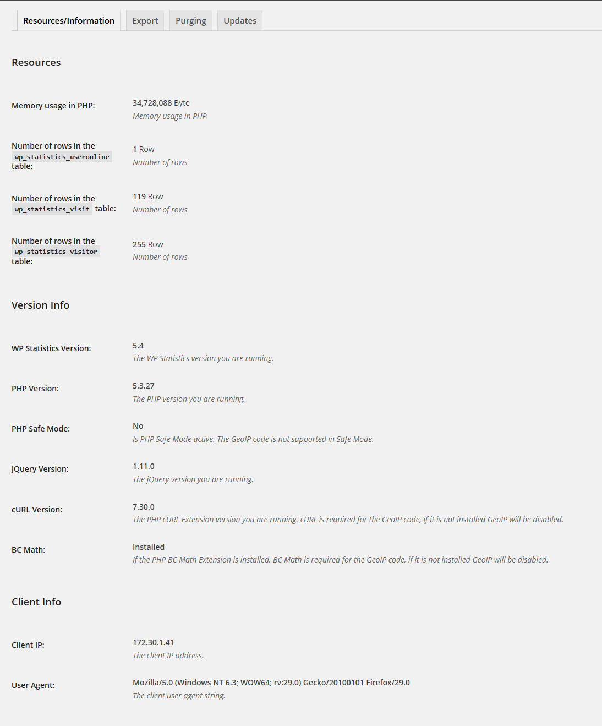
It has four tabs; Resources/Information, Export, Purging and Updates.

Resources/Information
The Resources/Information page has 3 subsections to it; Resources, Version Info and Client Info.

Resources
The Resources section contains some resource usage information.
Setting | Values | Description
Memory usage in PHP | Bytes | The number of bytes of memory WordPress is currently using. This number is highly trasitive and should only be used as a genera guide line. Pages like the overview page use more memory than others.
Number of rows in the wp_statistics_useronline table | Rows | The number of rows in the users online table.
Number of rows in the wp_statistics_visit table | Rows | The number of rows in the visits table.
Number of rows in the wp_statistics_visitor table | Rows | The number of rows in the visitors table.

Version Info
The Version Info section contains the various versions of the software installed on your server.
Setting | Values | Description
WP Statistics Version | Version | The version of the plug-in.
PHP Version | Version | The version of PHP.
PHP Safe Mode | Yes/No | Is PHP running in safe mode. Note this is the value in php.ini, so even though PHP 5.4 and above deprecated safe mode, you may still have the value set in php.ini. If you do, you should remove it.
jQuery Version | Version | The version of jQuery.
cURL Version | Version | The PHP cURL Extension version you are running. cURL is required for the GeoIP code, if it is not installed GeoIP will be disabled.
BC Math | Yes/No | If the PHP BC Math Extension is installed. BC Math is required for the GeoIP code, if it is not installed GeoIP will be disabled.

Client Info
The Client Info section contains some information about your current session.
Setting | Values | Description
Client IP | IP Address | The IP address you are currently connected from.
User Agent | String | Your user agent string.

Export
The Export page allows you to export the data from the database to a flat file. This is useful if you want to do additional analysis on the data or need to migrate to another statistics plug-in.
Setting | Values | Description
Export from | Table name | You can export from the three primary data tables.
Export To: | Excel, XML, CSV, TSV | The format to export to.  Excel will export an XML formatted XLS file (you may see a warning from Excel about the file not being in the correct format, you can ignore it).  XML will export an XML formatted file.  CSV will export a comma separated value file.  TSV will export a tab separated value file.
Include Header Row | On/Off | Include a header row as the first line of the exported file.

Purging
The Purging page has 2 subsections to it; Data and Delete User Agent Types.

Data
The Data section allows you to purge information from the database..
Setting | Values | Description
Empty Table | Table name | This will delete ALL data from the selected tables. Only do this if you are absolutely sure you want to reset all of your statistics.
Purge records older than | Number | Deleted user statistics data older than the selected number of days. Minimum value is 30 days.

Delete User Agent Types
The Delete User Agent Types section allows you to delete various user agent types from the database. This can be used to remove robots or other types of agents that are not real users.
Setting | Values | Description
Delete Agents | Agent name | This will delete ALL visitors with the selected agent type.
Delete Platforms | Platform name | This will delete ALL visitors with the selected platform.

Updates
The Updates page allows you to update the GeoIP data in the database for visitors that are missing the information. It also provides the current database size and file time.
Setting | Values | Description
File Date | Date/Time | This is the file date/time of the current database.
File Size | Bytes | This is the size, in bytes of the current database.
Countries | N/A | Selecting the “Update Now!” button will try and update any missing geolocation information in the visitors table. This can also be automated with the Statistics->Settings->GeoIP->Populate missing GeoIP after update of GeoIP DB setting.

Overview Page
The Overview page gives you a quick summary of all the statistics available, it looks like this:
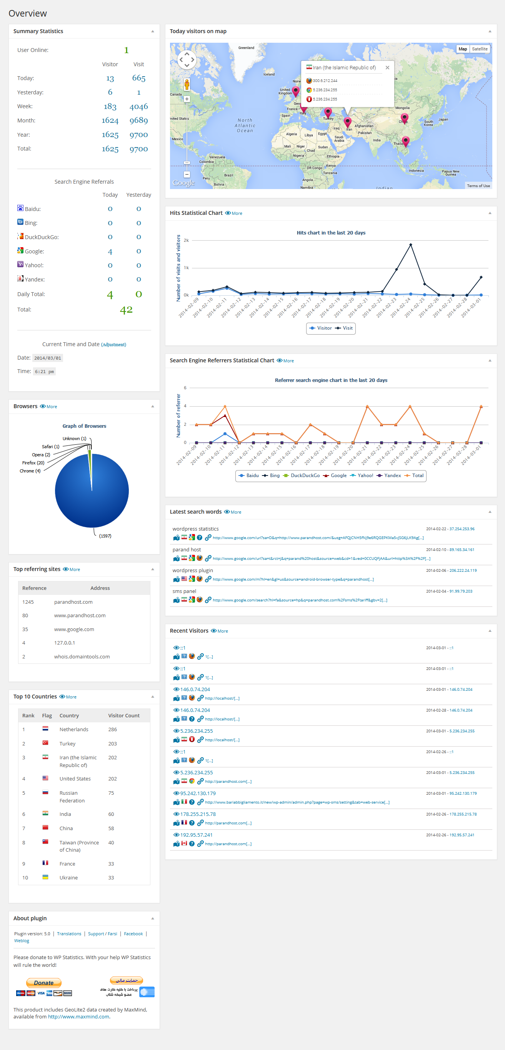
It contains several “widgets” to display information, these are; Summary Statistics, Browsers, Top referring sites, Top 10 Countries, About, Top visitors on map, Hits Statistical Chart, Search Engine Referrals Statistical Chart, Latest Search Words, Top Pages Visited and Recent Visitors.
Each widget is comprised of a header bar and a statistical body. The header contains three areas:
The title (Browsers in the above example), a “more” link (if applicable) and a “Minimize/Maximize” control (on the far right).
The “more” link will take you to a separate page with additional or more comprehensive statistics on the related items.
The “Minimize/Maximize” control will collapse/expand the widget. Note that the state of the widget is not saved between page views so they will re-expand the next time you visit the overview page.
The widgets are as follows:
Widget | Description
Summary Statistics | This displays today's and yesterday's statistics for the site. This includes the number of users currently online, visits, visitors and search engine referrals.  This widget also displays the current date and time (at page load). WP Statistics relies on the correct date and time as well as timezone being set on the server and in WordPress to display the correct information.
Browsers | This displays a pie chart (not configurable) of the different browser types that have visited your site.
Top referring sites | This displays the top 10 sites that have referred visitors to your site.
Top 10 Countries | This displays the top 10 countries of the visitors to your site.
About | This provides some details about the plug-in and the donation links.
Today visitors on map | This displays your visitors today on a Google map. This requires the GeoIP code to be enabled.
Hits Statistical Chart | This displays your visit and visitor counts in a graph format for the last 20 days.
Search Engine Referrals Statistical Chart | This displays the number of referrals you have received from search engines for the last 20 days.
Latest Search Words | This displays the last 10 search words referred to your site by search engines. Note that this is highly dependent on the search engine providing the information, some do not.
Top Pages Visited | This dipalys the top 10 pages that are visited for your site.
Recent Visitors | This displays the last 10 visitors to your site. This includes options to map their location, what country they came from and what browser they are using.

Browsers Page
This page provides details about the browsers users are using to visit your site. This information is presented in a series of pie charts.
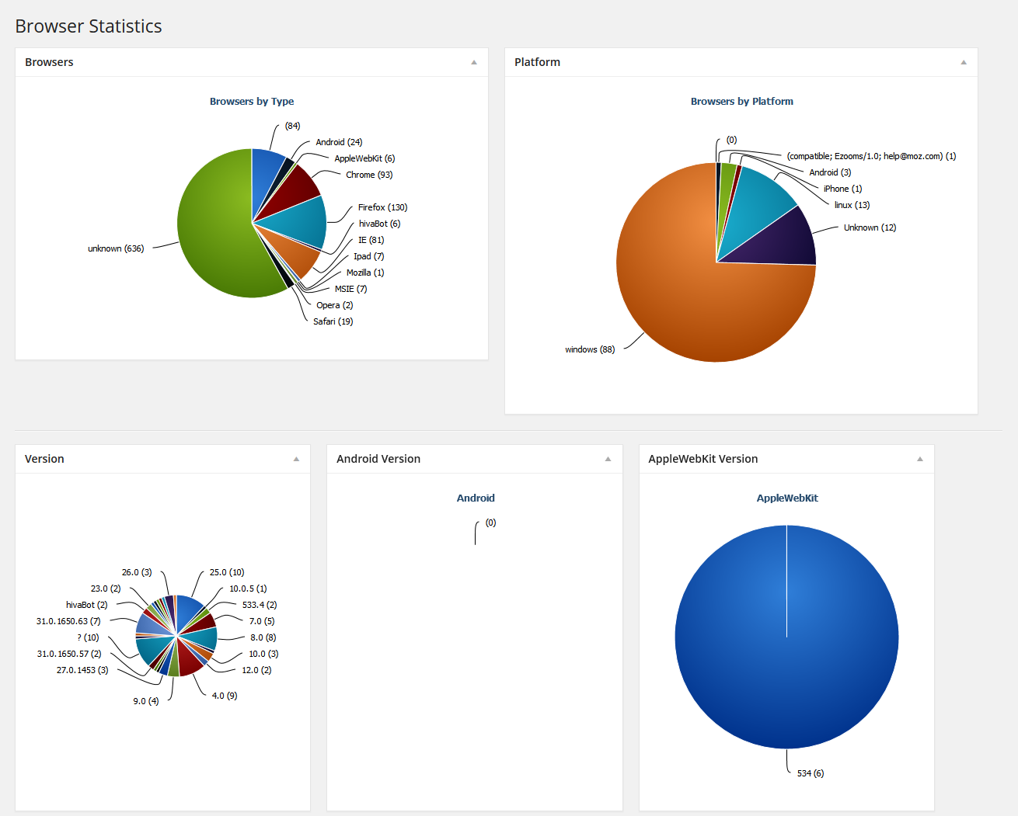
The first two pie charts provide details on the browser type and platform used. Teh rest of the pie charts indentify different version of browsers used.

Countries Page
This page provides details about the countries of users that have visited your site.
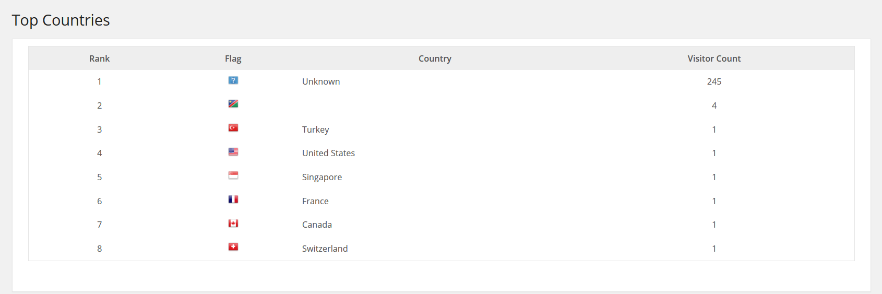
This chart will list all countries and includes the number of visitors from each.

Hits Page
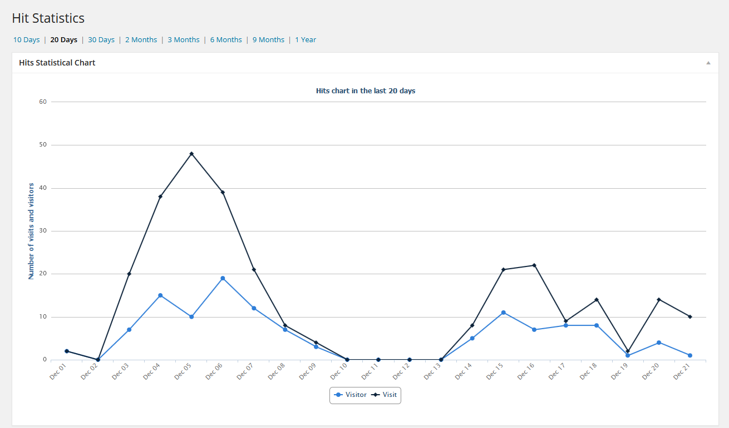
This page provides a trending chart for the total visitors to your site over a selectable time line.
The top part of the page allows you to select from
- 10, 20, 30 days increments
- 2, 3, 6, 9 months increments
- 1 year increment
Note that the longer the increment is the more data that is required to be processed. Large site with long increments can take significant time and memory to process.

Exclusions Page
This page provides a trending chart for the exclusion reasons if Statistics->Settings->Record Exclusions is enabled.
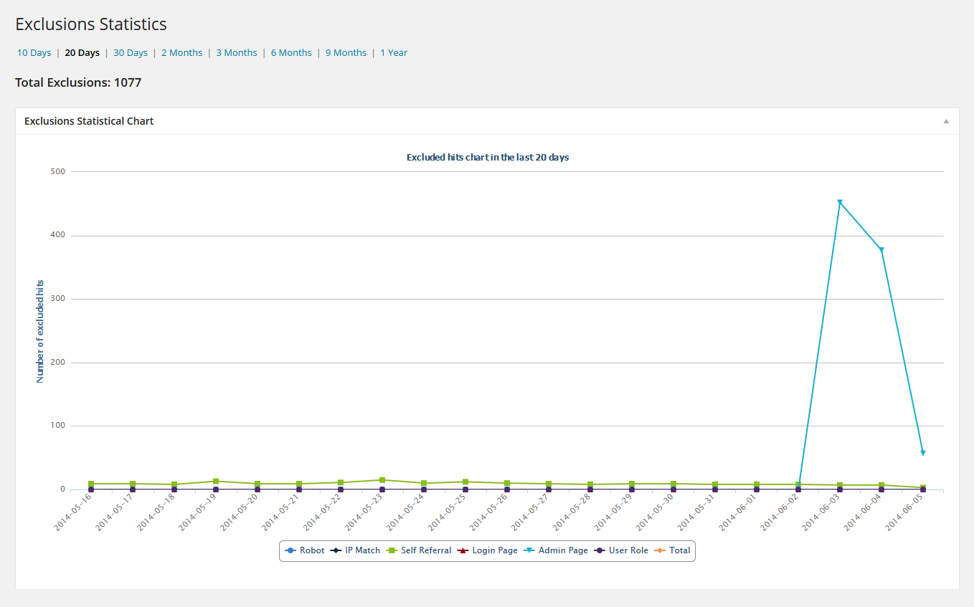
The top part of the page allows you to select from
- 10, 20, 30 days increments
- 2, 3, 6, 9 months increments
- 1 year increment
Note that the longer the increment is the more data that is required to be processed. Large site with long increments can take significant time and memory to process.

Referrers Page
This page provides a complete list of all referrers to your site.
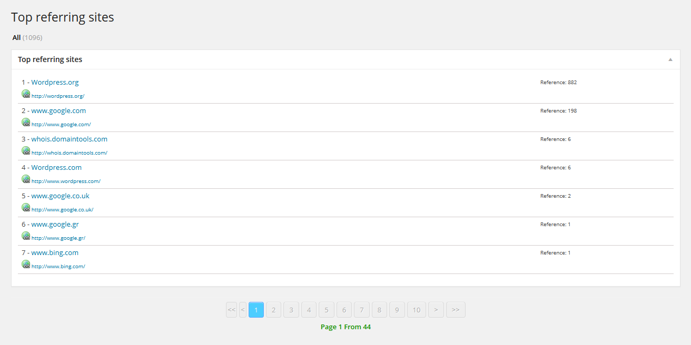
It is divided up in to pages of 10 entries each for easy browsing.

Searches Page
This page provides a trending graph of all incoming search engine traffic to your site.
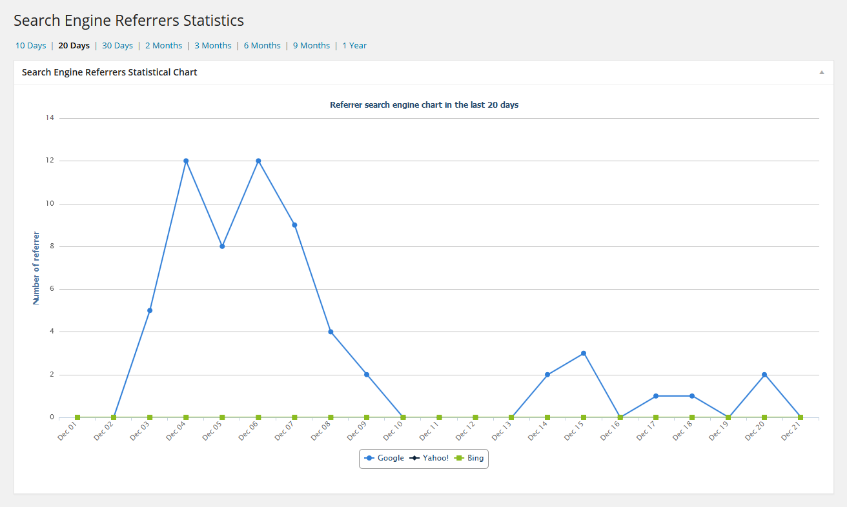
The top part of the page allows you to select from
- 10, 20, 30 days increments
- 2, 3, 6, 9 months increments
- 1 year increment
Note that the longer the increment is the more data that is required to be processed. Large site with long increments can take significant time and memory to process.

Search Words Page
This page provides a list of all search words from search engines to your site.
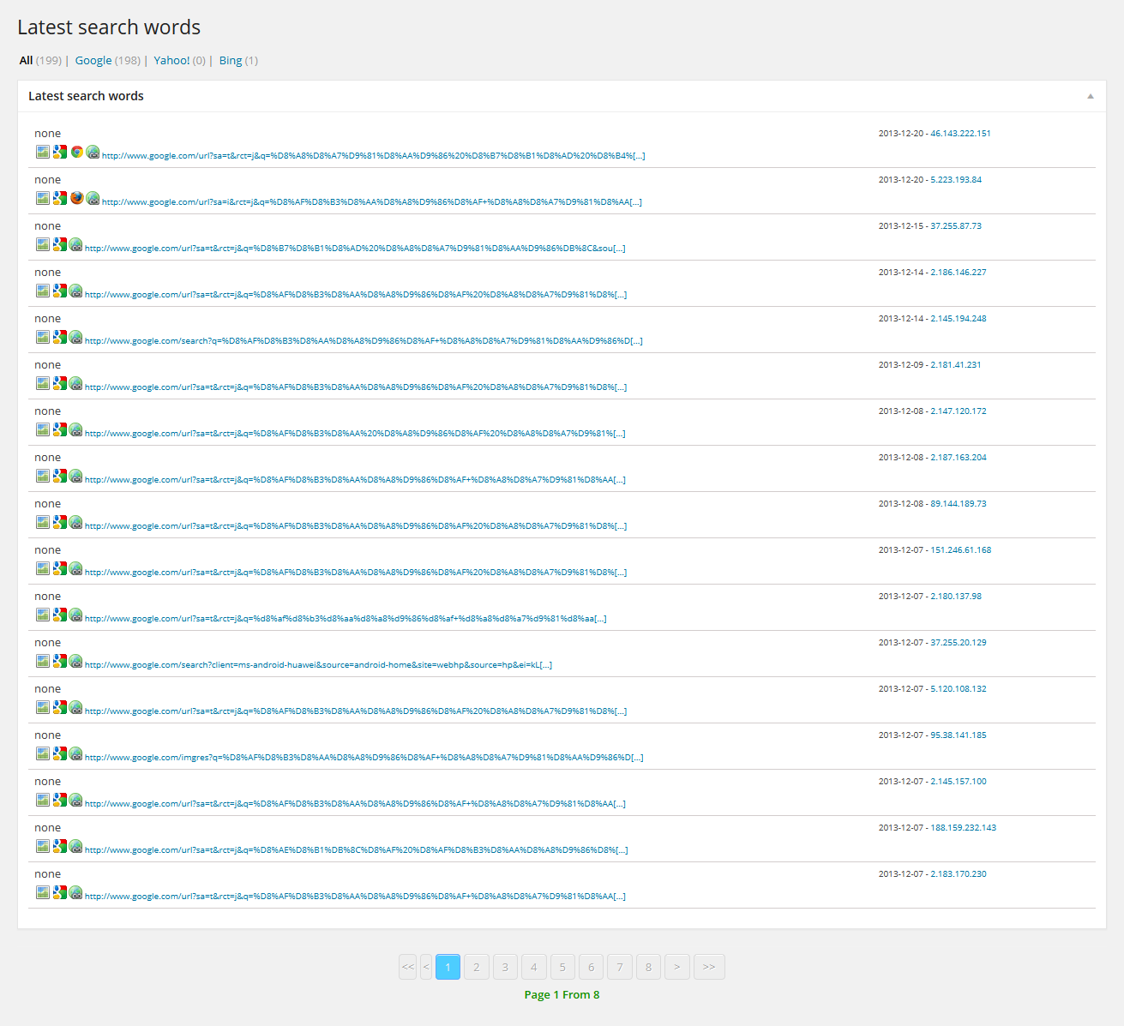
It is divided up in to pages of 20 entries each for easy browsing.

Visitors Page
This page provides a list of all search words from search engines to your site.
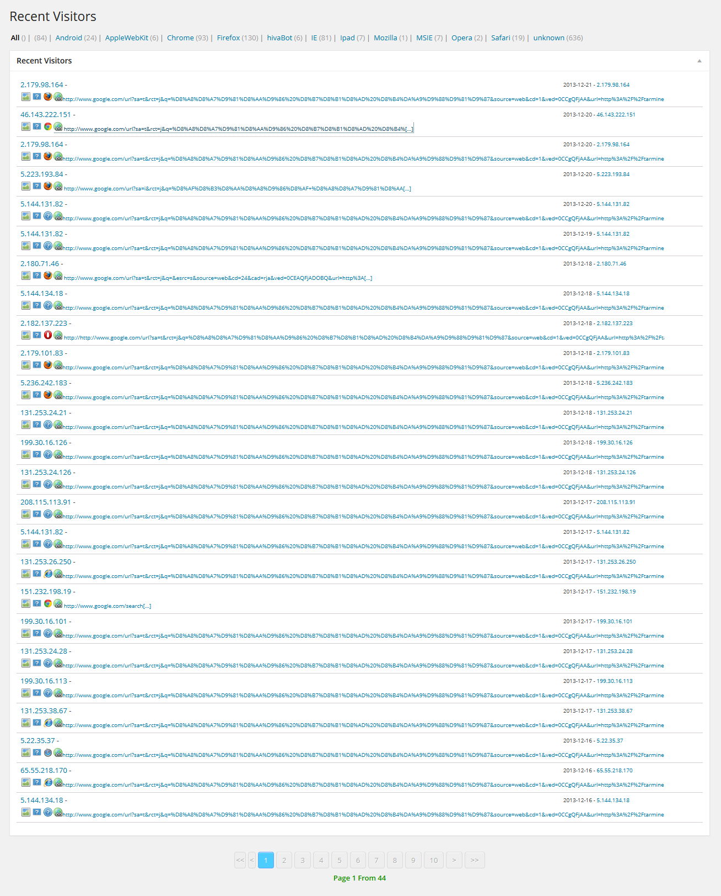
It is divided up in to pages of 20 entries each for easy browsing.

Pages Page
This page provides trending graph of your top five pages over the last 20 days as well as a complete list of all your page rankings divided up in to groups of 10.
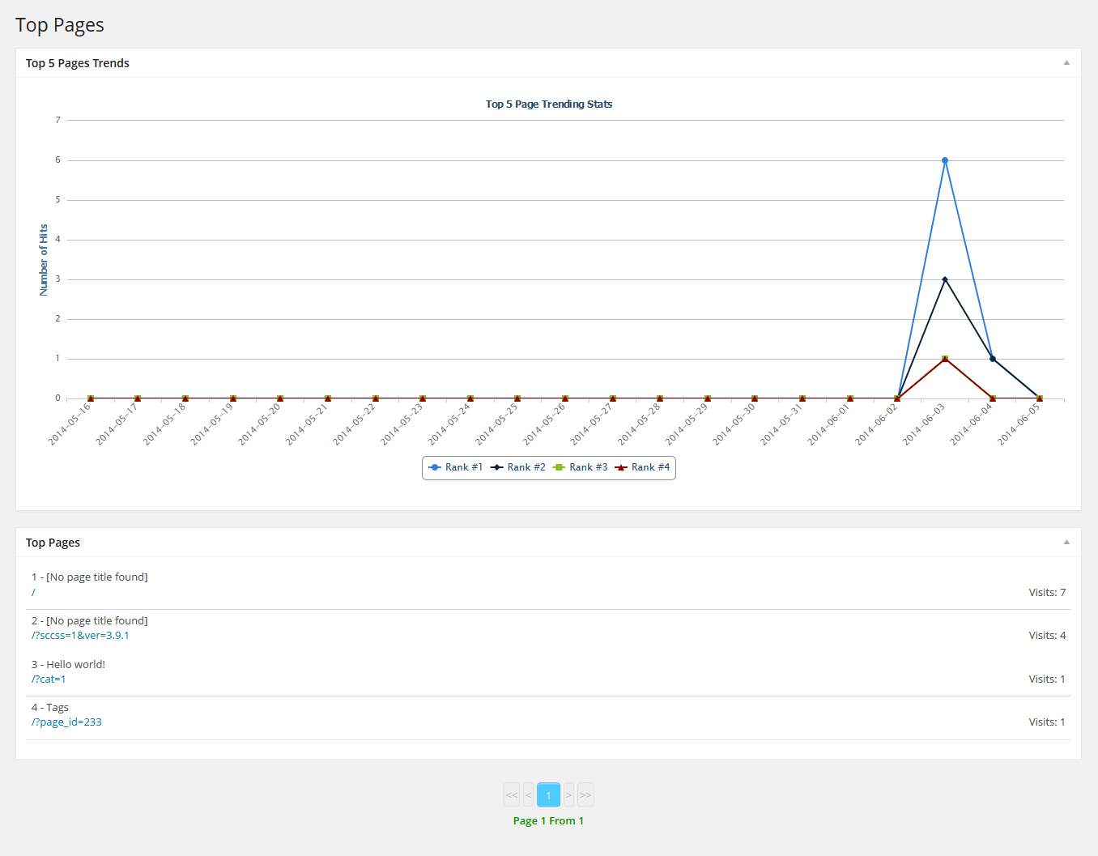
The list of pages contains the rank, page title (not all pages will have titles), the URI of the page and the number of visits.

The Widget
WP Statistics comes with a WordPress widget to display some statistical information to your front end. The widget is still supported, however you may find the shortcodes to be more useful as they can be used in an HTML widget with any custom formatting you may like to apply.
The widget is called “Statistics” and the configuration page looks as follows:
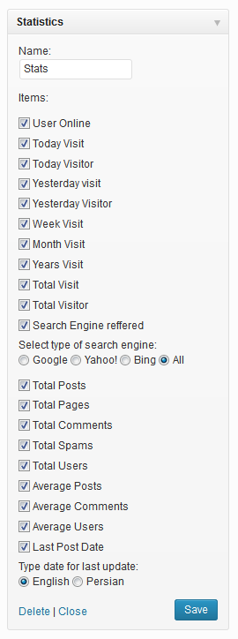
The name field at the top will be displayed in the header of the widget on your site. Each option that is enabled will be displayed on a single line in the widget and display the indicated information.

Shortcodes
WP Statistics supports shortcodes in WordPress, these can be used in either a post and page body as well as an HTML widget.
The general shortcode format is:
[wpstatistics stat=xxx time=xxxx provider=xxxx]
Where:
Item | Description
stat | The statistic you want, see the next table for available options.
time | Is the time frame for the statistic. This value uses the strtotime() PHP function (http://php.net/manual/en/datetime.formats.php) format, some acceptable values include:  - today  - yesterday  - week  - month  - year  - total  - "-x" (i.e., "-10" for the past 10 days)  Please refer to the PHP manual link above for a complete description.
provider | The search provider to get stats on (bing/duckduckgo/google/yahoo/yandex).

The “stat” field can be any of the following:
Stat | Description
usersonline | The number of users online right now.
visits | The number of hits to the site.
visitors | The number of visitors to the site.
pagevisits | The number of times the current page has been visited
searches | The number of search engine referrals.
postcount | The total number of posts on the site.
pagecount | The total number of pages on the site.
commentcount | The total number of comments on the site.
spamcount | The total number of spam comments on the site.
usercount | The total number of users on the site.
postaverage | The average posts per user on the site.
commentaverage | The average comments per user on the site.
useraverage | The average number of users on the site.
lpd | The last post date for the site.

Function API
WP Statistics supports several functions for other plug-in and theme authors to use to retrieve statistics about the site. All of the external functions can be found in:
wp-statistics\includes\functions\functions.php

Function | Description
wp_statistics_useronline() | Get the number of users online
wp_statistics_visitor(time) | Get the number of visitors
wp_statistics_visit(time) | Get the number of visits (hits)
wp_statistics_pages(time,uri,id) | Get the page views for a given page
wp_statistics_uri_to_id(uri) | Get the page ID of a given uri
wp_statistics_get_top_pages() | Get all pages sorted by number of hits (high to low)
wp_statistics_get_uri() | Get the current page's uri
wp_statistics_searchengine(provider, time) | Get the number of search engine referrals
wp_statistics_ua_list() | Retrieve a list of all visitors user agents
wp_statistics_useragent(agent) | Retrieve the number of visits from users with a specific user agent
wp_statistics_platform_list() | Retrieve a list of all visitors platforms
wp_statistics_platform(platform) | Retrieve the number of visits from users with a specific platform
wp_statistics_agent_version_list(agent) | Retrieve a list of all visitors agent versions
wp_statistics_agent_version(agent, version) | Retrieve the number of visits from users with a specific agent version
wp_statistics_searchengine_list(all) | Retrieve a list of search engines, by default this only returns search engines that are active, setting all to TRUE will return ALL search engines
wp_statistics_searchword_query (search_engine) | Returns the SQL query portion to find all search word queries for a given search engine
wp_statistics_searchengine_query (search_engine) | Returns the SQL query portion to find all search engine results for a given search engine
wp_statistics_searchengine_regex (search_engine') | Returns the regex to determine if a Referral URL is from a search engine
wp_statistics_countposts() | Total number of posts on your site
wp_statistics_countpages() | Total number of pages on your site
wp_statistics_countcomment() | Total number of comments on your site
wp_statistics_countspam() | Total number of spams items on your site
wp_statistics_countusers() | Total number of users on your site
wp_statistics_lastpostdate() | Last post date
wp_statistics_average_post() | Average number of posts
wp_statistics_average_comment() | Average number of comments
wp_statistics_average_registeruser() | Average number of users

Where:

Item | Description
time | Is the time frame for the statistic. This value uses the strtotime() PHP function (http://php.net/manual/en/datetime.formats.php) format, some acceptable values include:  - today  - yesterday  - week  - month  - year  - total  - "-x" (i.e., "-10" for the past 10 days)  Please refer to the PHP manual link above for a complete description.
provider | The search provider to get stats on (bing/duckduckgo/google/yahoo/yandex).
uri | The uri of the page you want to get statistics for. This should only be the portion of the URI after your WordPress base directory. So if the full URL of the page you want is:  http://example.com/wordpress/index.php?p=5  then the uri field should be:  /index.php?p=5
id | The post or page id you want to get statistics for.

